[Management](https://blog.cake.hr/category/management/)

Top 50 Team-Building Games that Your Employees Would Love to Play

Organizational success is largely dependent on how fast and in what way its people connect with each other for mutual benefit. And this eclectic collection of top 50 team games would help you do just that!

[](https://blog.cake.hr/author/norberts/)

[Norberts Erts](https://blog.cake.hr/author/norberts/)

August 10th, 2016

[Ken Blanchard](https://twitter.com/kenblanchard), management expert and author of the famous book “The One Minute Manager” came up with a genius of a quote that goes like this – “None of us is as smart as all of us”, simple words with a lot of weight.

Teamwork has been at the center stage for many years as far as employee-focused initiatives are concerned and its value in bringing about workplace happiness has remained non-debatable.

The article attempts to capture and present top 50 team-building games that would help to infuse fun and creativity in your efforts to build organizational dream team/s.

Why business needs team-building games or exercises?

With the time we spend with our co-workers, the benefits of investing time and money in teambuilding cannot be overemphasized.

The most obvious benefits of doing team-building initiatives at work include:

Facilitates collaborative and motivated work culture as these activities are seen as a move towards bringing individuals together

Helps in agile problem solving and decision making as many heads/hands contribute in the process

Fosters responsive and meaningful communication as employees come to know personality, desires, strengths and weaknesses of their co-workers

Aids use of creativity and out-of-the-box thinking by moving employees away from the usual job set up that recharges and refreshes them

Creates atmosphere to enhance productivity by identifying and eliminating obstacles or by improving existing ways of working

Boosts employee morale as they feel the company and colleagues are interested in knowing and developing them, a valid reason for employee retention

Simple games or brain teasers can also keep everyone awake during [morning meetings](https://biz30.timedoctor.com/morning-meeting-activities/). It helps creative juices flow, which in turn makes your meetings more productive.

Finally, the learning and insights from team-building games can be transferred to the actual work environment resulting in better work equations and organizational performance

Top 50 Team Building Games for Energized Fun Learning

1) Egg Drop



Messy on the surface but high on collaboration and engagement, Egg Drop is a classic team building game that unites groups on creative problem solving.

The idea is to build egg package/carrier that can keep the whole uncooked egg intact by sustaining a 2-4-storey drop.

Material for making the package usually includes straws, tape, plastic, balloons, rubber band, newspapers and the entire activity lasts for about 1-1.5 hours. The team that survives this free fall is the winner. In case of a tie, increasing the height for the egg-fall serves as a tiebreaker.

2) Dog, Rice, Chicken



A game that gets your grey-cells turbo charged with lateral thinking and planning – dog, rice, chicken encourages creative problem solving within team.

One of the group members is allotted the role of a farmer and the rest team acts as villagers. The farmer has to return home along with its 3 purchases (Dog, Rice and Chicken) by crossing a river in a boat. He can carry only one item with him on the boat.

He cannot leave the dog alone with the chicken because the dog will eat the chicken, and he cannot leave the chicken alone with the bag of grain because the chicken will eat the bag of grain. How does he get all three of his purchases back home safely?

The villagers can help him in arriving at the solution, which is really simple if the group thinks creatively and together.

3) Talking in Circles



This is a very fun and challenging game that requires lot of communication and coordination among the teammates.

The group is asked to stand in a circle around a long piece of string tied at the ends to form a circle. The team is next asked to create shapes with the string – square, triangle, figure 8, rectangle and many other shapes.

To increase the difficulty level, the members are asked to shut their eyes/be blindfold and repeat the exercise. To further the complexity of task, random team members may be “muted” at different times thereby making communication more challenging.

This activity also tests the level of leadership and trust within a group.

4) Two sides of a Coin



Building on the timeless notion of positive and negative from a single experience, team of 2 or more come together and discuss a situation.

For instance if there are two members, Partner A shares something negative that happened in their life with Partner B. It can be a personal or professional memory, but mandatorily a true incident.

Then Partner A discusses the same memory again, but this time focusing on the bright side with positive takeaways. Partner B helps sheds light on the silver lining of the negative experience. Afterward, they switch roles.

This short yet effective activity helps team members see the good in things and people and challenges the preconceived notions.

5) Blind Drawing



A team activity that encourages communication, especially listening – blind drawing is deceivingly simple yet effective.

The game requires 2 players to sit back to back, where one team member is given a picture of an object or word. Without specifying directly what the thing is, the person must describe the image without using words that clearly give away the image.

These should be non-related words for instance – if it is a “flower” then the person can describe it as hearts put together (to form flower petals), a string/rope holding the hearts (Stem), rain/water drops (leaves) and so on. The person with pen and paper draws the object based on the verbal description and their own interpretation.

The final outcome is fun to see and depict whether 2 members can effectively communicate, imagine, and innovate in each other’s company.

6) The Mine Field / Watch your step



Select an open area like a parking lot or a park for doing this activity.

Prepare an enclosed area with tape and mark the start point and end point. Along the route place several handheld objects/toys randomly at specific distance. Divide the group into teams of 2 or 4 and blindfold one of the members.

The others stand outside the enclosed area and verbally instruct the blindfolded teammate to navigate across the route, picking up the toys and avoiding stepping on sheets of paper (mines) or outside the enclosed area. This highly engaging game takes about 15-30 minutes and is awesome to convey learning on trust, active listening and communication.

To make it more difficult, create specific routes the blindfolded team members must walk or only allow certain words/clues to be used for guiding.

7) Three Truths and a Lie



With absolutely no tools required, this team building game could be done anytime and anywhere without much hassles.

All you require is 3 or more members sitting in a circle, with each person taking turns to state four facts about self, out of which 3 are true and the remaining 1 is a lie. The instruction is to frame the lie realistically rather than making it look hard to believe and easy to guess.

Once the facts are stated, the other team members take turns to identify the lie from the 4 statements. Once all are done with guessing, the right answer is revealed at the end.

The game works wonder for new or geographically scattered teams who can benefit by knowing more about their teammates. It challenges preconceived judgments and helps introverts to open up in a group set-up.

8) Team Birthday Line Up



A great icebreaker team activity, this quick and simple game is recommended for training that involves focus on problem solving, communication and cooperation.

The participants are asked to fall in line side-by-side. They are then asked to rearrange their line in order of their birthdays (considering only the month and date). What’s the catch? The challenge is that the group members cannot talk at all. They can resort to using sign language, nudges, and other techniques to determine each other’s birthday.

This is ideal team challenge game for more than 8 participants and you might see some members taking lead and directing the members to achieve desired outcome.

Variation to the game involves blindfolding couple of participants, using platform/bench for members to stand – where if anyone falls, the group has to start all over again.

9) Tower of Hanoi

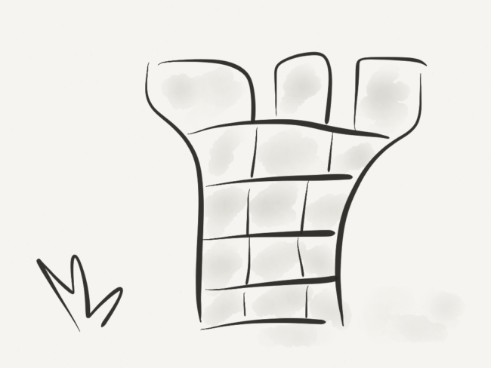

This team building game with a mathematical twist allows for ample group discussion, planning and problem solving within the participants.

The puzzle consists of three towers/posts/rods with 5 or more discs arranged in conical shape with smallest at the top. The objective of the game is to move the entire stack to another rod retaining the particular order. There are few conditions to be followed while playing this game:

1) At a time, only one disc can be moved from the tower

2) Only the uppermost disc on a tower can be shifted and

3) the team is not allowed to put a larger disc on a smaller disc.

The minimum number of moves required to solve a Tower of Hanoi puzzle is 2n – 1, where n is the number of disks.

10) Frostbite



This game tests the teams’ instinct to survive in the worst.

Divide everyone in groups of four or five. The scenario is that the teams are lost in arctic and they need to build a shelter to withstand the cold winds. The team elects a leader who is supposed to be suffering from frostbite, so he cant move physically while other team members are supposed to be struck by snow blindness and must be blindfolded.

The leader instructs the team on how to build the shelter without manual helping and the teammates must do so without being able to see.

11) Penny for your thoughts



Team members are often hesitant to open up with each other and this hampers fluid conversation.

To help loosen up teammates and feel comfortable, the game penny for thoughts is perfect icebreaker. This involves collecting pennies/any other coins with listed year and dumping them in a container or box. The important thing to note here is that any of the coin shouldn’t be dated older than the youngest team member.

Next, each of group participants draws out a coin and based on the listed year, the person has to share something significant/memorable/special that happened to them in that year.

This gives interesting insights into the lives of your teammates and makes future interactions stress-free.

12) Pencil Drop



All you need to carry out this hilarious activity are some pencils, strings, and water bottle.

This fun game breaks the tension within the group and allows for great one-on-one bonding. To do the pencil drop, tie one of the ends of both the stings at the eraser-end of the pencil and tie the remaining two open ends around the waist of two team members facing their backs to each other.

Ask them to move back and back in order to lower down the pencil into the water bottle placed on the floor below. The participant pair is not allowed to use hands and this can be done as a standalone fun challenge or different pairs can do this at the same time as a race.

13) Flip it Over



If you want your team to understand the nitty-gritties of working together and collaborating in true sense then “flip it over” is your game.

Ask 6-8 participants to huddle together and stand on a blanket/towel/tarp, leaving a quarter of the portion empty. Challenge the group to flip over the tarp/blanket so that they are standing on the other side of the sheet. And all this without getting off the blanket or touching the ground outside the sheet.

This will force the group to think of creative solutions and truly work together in achieving the common goal. It will also highlight the problems that pop up if any team member refuses to cooperate, creating a dilemma for the others.

14) Zoom



Everyone loves pictures. And this game gives just that.

The activity takes about 30 minutes and there are 30 sequential pictures that work together to form a narrative. The pictures are distributed to the participants and are asked to not reveal it to the others. They can of course talk and describe what features on their picture. The task calls for creating a unified story and placing the pictures as per the sequence, without the teammates looking at one another’s pictures.

This game gives lot of scope for learning certain crucial things like – communicating intelligently with patience, appreciating others’ viewpoint, making sense of the information at hand and for leaders to emerge and take control of the situation.

15) Salt and Pepper

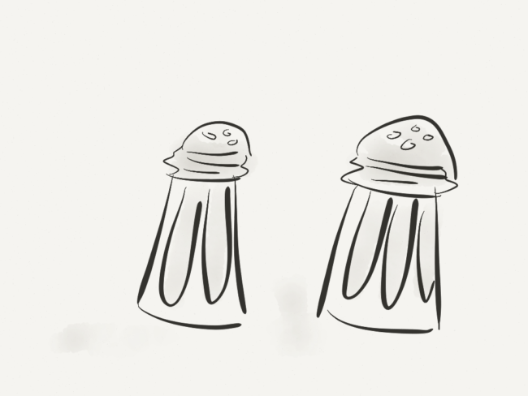

The art of asking right questions in team is very important. Salt and Pepper is an extremely appealing way to learn facts about team members and also assess one’s ability to communicate effectively with other members.

It requires simple stationery like pen, tape and paper to set the ball rolling. Pair-Words are thought and written on different sheets of paper like Yin-Yang, Bread-Butter, Salt-Pepper, Sun-Moon, and so on. If Salt is written on one paper, Pepper will be written on totally different paper.

One paper is taped on the back of each person, without letting him or her see what’s written. The group is instructed at the same time to search for their partners. The fun is that they can only ask “Yes-No” questions in order to find out what is written on their back. Once they figure out the answer, they can find their respective partner easily.

16) Spider Web



Though bit demanding on the logistics front, Spider Web makes for amazing team building game with its ability to make the group members learn valuable lessons in persistence, cooperation, leadership, support and trust.

A web is built using large ball of string and duct tape, between two-pillar posts/tree or any other solid fixed pole like object.

Each team gets a point every time someone passes through a hole of weaved web without touching the string. Once a particular hole is used to pass by someone, it gets closed for subsequent members. This requires strategizing on part of the team in terms of safety and suitability of different passages for different team members.

17) The Barter Puzzle



This activity lasts for 1-2 hours depending upon the level of cooperation/negotiation and speed of decision-making among different equal-sized groups.

Each group is given different jigsaw puzzle with same level of complexity. The team that is able to put all the pieces together in least possible time is the winner.

The challenge comes with puzzle pieces being mixed with other groups’ jigsaw puzzle. The team has to come up with ways to get the pieces back through negotiation, trading, exchanging team members, etc. However it should be a group decision and not individual choice. This calls for great deal of problem solving and consensus building within the group.

18) Human Knot



This game combines team fun with communication and creativity.

The participants are asked to stand in circle, shoulder to shoulder, facing inside of the circle. Each member is asked to extend his or her right arm and grab hand of someone standing across the circle. And the same is repeated with left arm. There are two conditions to follow –

1) Everyone should hold hands of two different people

2) No one should hold hand of someone who’s standing directly next to them

The objective of the game is to untangle everyone forming the human knot without breaking the circle. If the chain breaks, the group has to repeat the exercise.

19) Goodie Bag Skits



A great way for people to step out of comfort zone and feel comfortable with colleagues is to make them perform together.

And skits are not only entertaining but allow for planning and collaboration among team members. This game works well for large group of people with around 20-50 participants. They are then divided into teams of 3-8 people and given goodie bag with multiple random items.

Each group is given 5-10 minutes to prepare a skit and perform it under 3 minutes. Topics can be chosen by teams or can be predefined by the facilitator. Groups perform based on the creative use of items in the bag. Other teams watch the performance and once all are done performing, winner can be declared based on team voting.

20) Balloon Questions

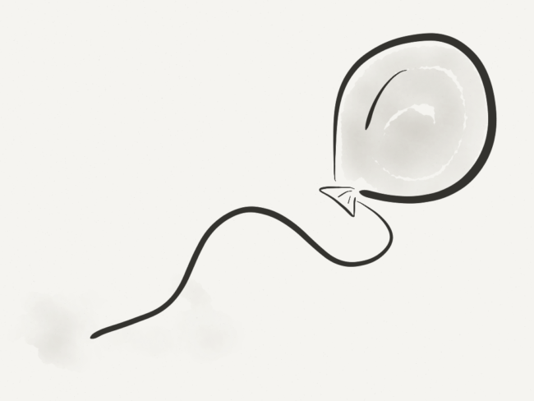

When new/scattered/virtual teams are concerned, the objective is often to learn more about other team members in a stress-free, fun and interactive way.

Balloon Questions is the ideal choice in such scenarios. All you need is balloons, paper, and pens/pencils. Give each person a balloon and a small strip of paper. Ask them to write down a question on the slip of paper and place it in their balloon, then blow the balloon up and tie it.

Once everyone has finished, instruct the group to hit their balloons into the air, trying to keep all the balloons in the air for as long as possible. After a few seconds tell everyone to grab any balloon (other than their own) and sit in a circle. Each person takes a turn popping his/her balloon and then answering the question. For small groups you may have each person in the group answer every question.

21) Scavenger Hunt



This team building activity never fails to amuse and always encourages teams to collaborate creatively.

Break the group into two or more teams depending on total strength of participants. Make a list of items to be found or things to be done by each team with deadline. The first team to accomplish all the listed tasks wins!

This exercise can be made more fun by including riddles, clues, twists etc. to lead their way to final items. Scavenger Hunts are popular to foster teamwork and creativity among inter-functional and non-related teams.

22) Helium Stick

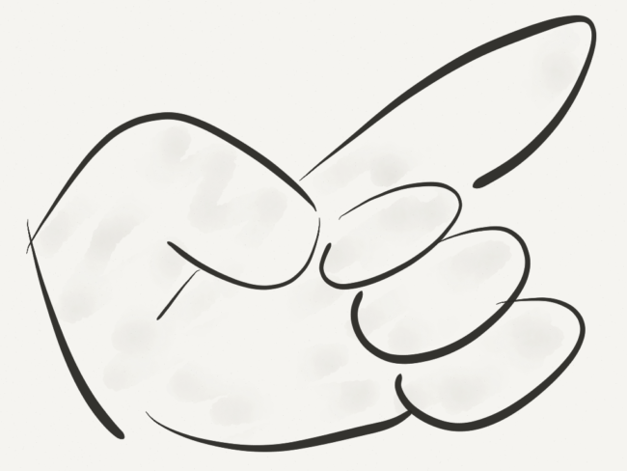

A task that can be funny and frustrating in equal measures, Helium Stick or Magic Cane activity is very useful to drive lessons in teamwork to achieve common mission.

Have the group of 8-12 members break into two lines and face each other. The mission is to lower a stick to the ground without letting it fall. But where does the stick rest? The stick is placed on the index fingers of participants (without grabbing or finger curling).

A seemingly simple activity becomes a daunting task as the stick rises almost instantly due to the small upward pressure exerted by fingers of participants in order to remain in contact with the stick. This stirs up mix emotions of confusion, laughter and annoyance till the group learns to focus and unite to lower the stick.

23) Scramble Puzzle



The idea behind this activity is to establish high levels of trust, leadership and communication among different members in the group.

You need blindfolds, and 2 sets of very easy pre-school level puzzles. Have the team blindfolded and sit in a circle arrangement. One of the teammates is without the blindfold and has to sit outside with his/her back to the group.

Spread puzzle pieces across the table in front of the blindfolded group. The members must try to assemble the pieces and complete the puzzle. The person sitting outside will have the same puzzle in a completed format and can guide/instruct the blindfolded group in putting the puzzle together.

24) Marshmallow Spaghetti Tower

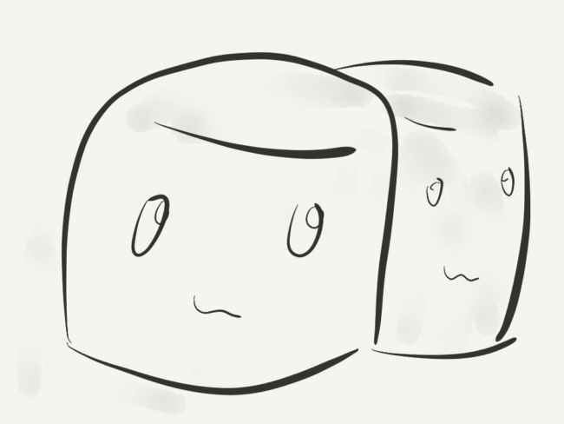

This particular game puts the best problem solvers in a fix, as they need real creativity and teamwork to put up a fragile tower.

Materials given to build the tower include sticks of spaghetti, roll of masking tape, string, and marshmallow for every team. Using these supplies, the teams have to build the tallest tower. The catch?

The tower has to stand on its own for five seconds without any external support with the marshmallow sitting pretty at the very top of the structure.

25) Memory Wall

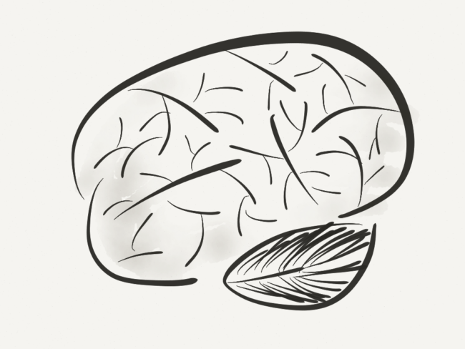

Nothing bonds teams better than positive experiences and memories built along the work timeline.

Put up a whiteboard and distribute post-it notes among the group members. Write down work-related themes on the whiteboard like “My First Day”, “Work Travel”, “Team Celebrations”, “Team’s way of working” etc. and let people write down special team memories and accomplishments related to any of the theme written on the whiteboard.

Take group members on a walk down the memory lane by asking everyone to share what they have written and post the same on the whiteboard wall. Teams will be left with nostalgic lingering smiles on their faces for a long time.

26) Desert Survival



This activity is a classic take on collaboration for the common good and tests team logic and problem solving skills to the hilt.

The group is given a scenario where a plane has crashed, leaving everyone stranded on a desert far away. A list of items that might be helpful for survival and rescue is given to the participants. Based on the importance and relevance of items, the members first prioritize and rank the items on an individual basis and then by group consensus method.

This 30-40 minute game helps to reflect on the differences between singular and collective choices, where our personal favorites might not match the group rank. It also shows how the team fares when a particular person/s overpowers the discussion or when member/s don’t put their views strongly.

27) Bonding Belt

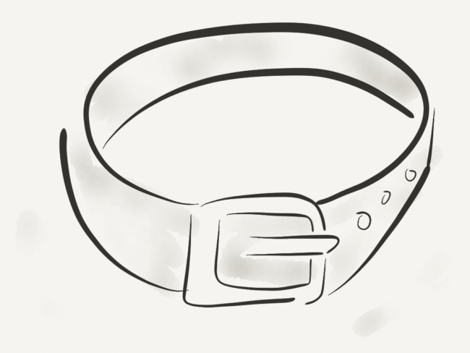

This is a fantastic team-building game that encourages discussions and developing strategy among co-workers and peers.

The game requires 20-30 minutes and just requires a cling tape/film or rope. Divide the group into teams of 5-6 and bind them together with tape or band so they are united in their movements. Their goal is to reach from Point A to Point B. They can be given 5 minutes to strategize before they begin the game.

Then let your teams run, and keep track of their end times. Once all teams are aware of their finishing times, give them an opportunity to re-strategize their next attempt in order to beat their previous score. Repeat this process as many times as you’d like until the teams achieve their best times!

28) 4-Way Tug-Of-War



Giving a fun take to the classic game of tug-of-war is its multidirectional variant that is as inexpensive and uncomplicated to execute as the original.

Tie ropes in such a way that three or four teams tug at once. This unexpected twist is sure to soar the competitive spirit and energy levels of the participating teams.

It also works as a way of instilling teamwork and sportsmanship value with some teams might choosing to work together to eliminate other groups before going head-to-head with one another.

29) Blind Wine Waiter



This game is a real treat for teams that are looking forward to loosen up with each other and are facing communication issues at workplace.

Make teams of 5-6 people, with one person acting as the leader and the rest as waiters. The waiters are to be blindfolded, while the leader has to sit on his/her hands. The goal is to serve wine to the leader, who has to drink it without using hands.

Next question is how to serve the wine? Each team is allotted 1 wine bottle, 1 glass and 1 corkscrew. These are kept around various locations in the room to be found by the blindfolded members. The catch is each team member can perform only one task and that too with just one hand i.e. If someone has found the glass, he can’t go and find wine bottle too.

The activity is considered to be over when the leader drinks the served wine from the glass.

30) Classify This



The goal of this exercise is to help teams revisit their thought process of viewing everyday things/objects and finding commonalities in seemingly non-related things.

Collect a variety of objects and put them in the center of the room on a table, so that it is visible to all the teams. These can be very different things and can be as varied as stationery, cake, toys, jewelry, umbrella and so on. Aim to gather around 25 different pieces.

Each group is given sheet of paper and pen. Next, they are instructed to classify the demonstrated things into 4 categories (you can decide on this number). Invite a spokesperson from each of the group to present how they classified things and the logic behind it (may be end-use, looks, some common traits, etc.) This gives a new out-of-the-box lens to view routine things in work and life.

31) Let Us Guess



This game is a derivation of the classic game of dumb charades.

The group is divided into small teams of 4-5 participants. One person in each of the teams is given a random object and is asked to wait away from the group so that the team cannot see the person or the object. When the turn comes, the person has to go up in the front and demonstrate the use of the object without speaking.

The rest of the team has to discuss and guess the name of the object. Each team gets 3 guesses, with highest points for right guess in the first go and subsequently lower scores for 2nd and 3rd time guess. The object chosen must be difficult and wacky to make it fun and challenging for the teams to guess.

32) What’s in the Room

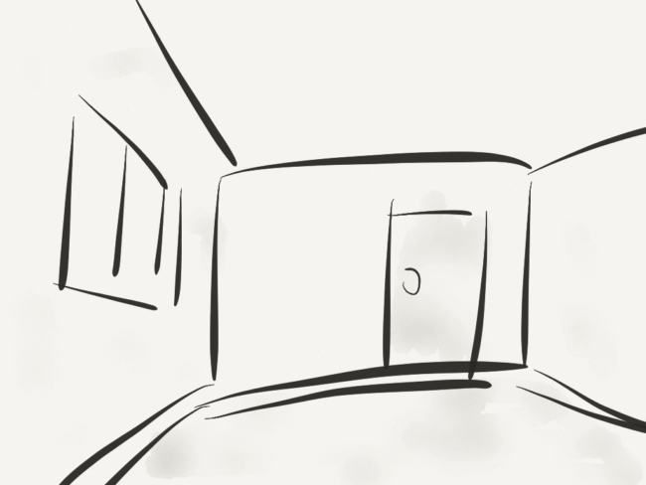

This game activity involves teams to pick up any random object in the room and prepare a marketing plan to sell it.

They must come up with a brand name, logo, slogan and detailed strategy to make their product a hit with the masses. All this has to be achieved within a set amount of time. Once the time is up, ask the group to present their object creatively and try to sell it at a profitable rate to the other teams.

The team that could sell the product at highest profit with most enticing marketing plan is declared winner. Discuss with the entire group on the reasons behind the successful selling spree of winning team and what other teams could have done better.

This helps the group to see the same things in new light and come up with crunch-time ideas and problem solving.

33) Perfect Question



Divide the group into teams of 5-6 members and assign each member some scenario, for instance – someone getting married, opening a restaurant, leading an army troop, acting as a hiring manager, and so on.

For each person’s scenario, the rest of team members have to ask just “one” question. This question should test if the person is a perfect fit for that scenario i.e. how effectively he/she can handle that scenario.

The team members can write down their question for each of the scenario and when all the scenarios are covered, they can discuss in the group and see which team member framed the “perfect question” for a given set-up.

This exercise helps members to evaluate how differently others think on same issues, their motives, priorities, leadership abilities, etc.

34) Hear Me Out

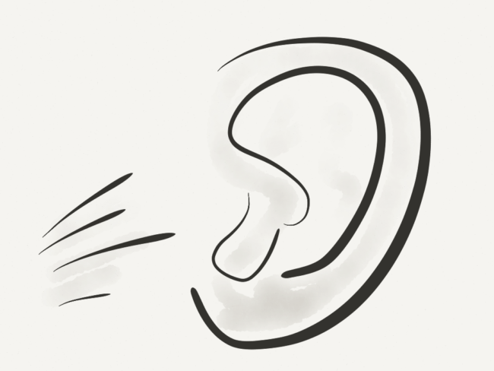

Many problems in the team arise owing to conflicts due to misconstrued and partial listening.

A good communication is the one, which combines verbal and non-verbal cues in balanced manner. Based this premise, Hear Me Out requires one of the team members to read out loud a document in front of the other members. However, the document involves many mind-numbing yet coherent jargon and non-related phrases. The document is to be read out in monotone without emphasizing on the “real” sentences.

The remaining members are given a sheet of paper and asked to write down what they thought the document was about. You can also quiz them on random information within the document and discuss who heard what, including reasons for them to tune you out.

35) Triangle Turn



Ask the group members, except one of them, to stand side by side to form an outline of a Triangle.

The excluded team member is called the “Spinner”, who stands inside the triangle. The spinner is free to face any side of the triangle. Each teammate needs to remember their position with respect to the spinner as well as people standing on their either side. The spinner, without any warning has to spin in different directions, stop and stand still.

At that time, the team within set amount of time has to reassemble into the original place to face the spinner exactly the same way before he started spinning. This game not only pumps up adrenaline but also is high on collaboration, as team members need to support and remind each other to acquire the correct places for winning.

36) Last 30 Seconds



This activity helps team members to know one another better by having a glimpse into their desires, personalities and passions.

The game is simple. Participants get a minute to remember and consider the best and defining moments in their lives – it can be anything exciting, adventurous, life-changing or rewarding in personal or professional space. The search is narrowed down when they are asked to choose only moment that they would like to relive in the “last 30 seconds of their lives”.

The second part of the game allows participants to know each other at intimate level as each one of them share the highlights of the last 30 seconds of their lives. This unpretentious game brings cohesiveness among distant or troubled teams.

37) Sneak a Peek

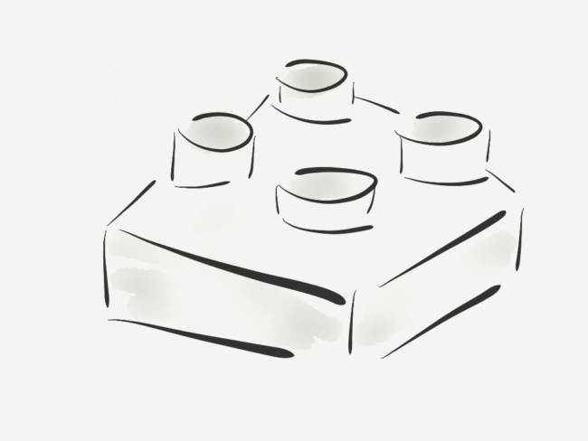

Communicating effectively and playing on strengths of individuals is what good teamwork is all about.

This game helps to bring out both these qualities. A structure is built using Lego blocks or building blocks and is presented by the instructor to the teams for 30 seconds. It is immediately hidden from the group and each team is given enough material to replicate and build the same structure. The original structure is kept at an equidistant location from the teams but hidden at all times.

One member from each team gets a chance to catch a glimpse of the structure for 10 seconds and brief the group for another 25 seconds to help them build exact duplicate of it. This is repeated again with some other member from the group. The team that is first to successfully replicate the model becomes the winner.

38) Bob the Builder



You need 10 paper cups and open area for this activity.

Divide the group into teams of 4-6 each. Ask them to stand in a straight line with a distance of 8-10 feet between the participants. At the announcement of word “Go”, the first player on each team has to build a pyramid with 4 cups at base.

Once finished, he and the second player on his team try to carry the pyramid from his spot to the place of second player. If they drop the pyramid, they can re-build it from where it fell and continue their walk.

When they reach the next spot, the second player tumbles the pyramid and rebuilds it to advance it to the third player’s location. This continues till the pyramid reaches the last players’ spot, when all the members have built, moved and tumbled the pyramid. The players are free to choose on how they would move the pyramid – by carrying it, with support or by sliding it.

39) Paper Plane Contest



The game brings about creativity, strategizing and collaboration skills among the group members.

You will need a long hallway, tape to mark launch line, measuring stick and card/paper stock to carry out this exercise. Each team is given card stock to construct a paper plane.

A variety of plane designs can be shown to the entire group so as they can strategize and build the one they think will fly the farthest. Add to the fun by asking them to name their airlines with brand logo and slogan. The team whose plane flies the farthest wins the flight fame.

40) Zombie Escape

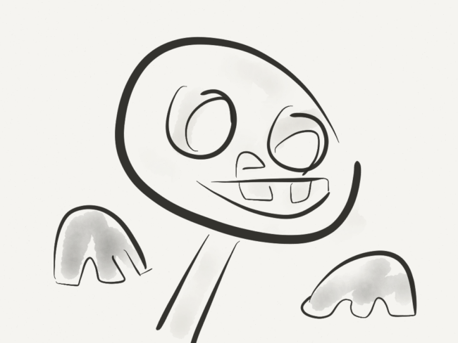

Lead the team in a dim-lit room, which is big enough to hide clues or puzzles. Lock the door.

Create an atmosphere of horror and distraction with sound, visuals and light effects that replicates a zombie apocalypse scenario. The team members will be required to solve the puzzles and find the hidden key that unlocks the door and allow them to escape this scene of dreadful dead.

The game taxes the group to come up with creative solutions amidst confusion, terror and lot of distractions. Plus the activity is high on fun quotient bring the team together in true sense.

41) Shoe Scrambler

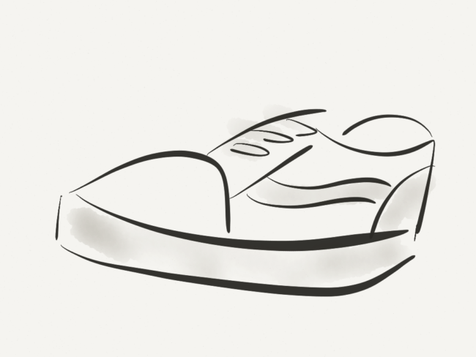

This game works wonders when the idea is to loosen up the team members and increase their camaraderie by cheering fun.

Ask all the team members to take off their shoes and throw them into a big pile. Mix them around. Break the group into small teams and ask them to stand in straight line, slightly away from the pile. The first player of each team runs to the shoe pile at the same time, sorts out his/her own pair, puts them on and ties them back up.

The player then runs back to his/her respective line and gives a hi-five shouting, “Go” to the next member in line (like a relay). This new person does the same thing. The first team wearing footwear (with shoelaces laced) wins.

42) Human Spring



A very effective game to drive home the lessons on interdependence, trust and cooperation is the game of Human Spring.

The group members are asked to pair up with similar sized teammates. The pair has to face each other, with elbows bent, hands up and palms forward facing each other. Instruct them to touch their palms together and gradually lean towards each other so that they eventually hold each other up.

Ask everyone to move their feet further and further back, so that they have to depend solely on their partners to remain standing. You can ask the member to switch the partners to see if they can go further apart to set new record. The pair with furthest distance between their feet wins or if its done in fun then add up everyone’s’ distances for a grand total.

43) Photo-Shoot



Photo-Shoot is a great way to encourage teamwork and task distribution, thereby fusing entertainment and learning together.

Split the group into teams of 4-5 and ensure each one of the members has a camera phone. Draw up a list of things/objects/situations/people that they need to capture as a team. The list can be creative and tricky at the same time. Based on the difficulty level, allocate different points for different things on the list.

Allocate a specific time limit for the teams need to meet back. Tally up the points and team with maximum score is the winner. Some examples of things that can be included on the list include – teammate in a swimming pool, a cat, Turn Right signboard, a kid on the swing, a personalized number plate, a particular slogan etc.

44) Human Shapes

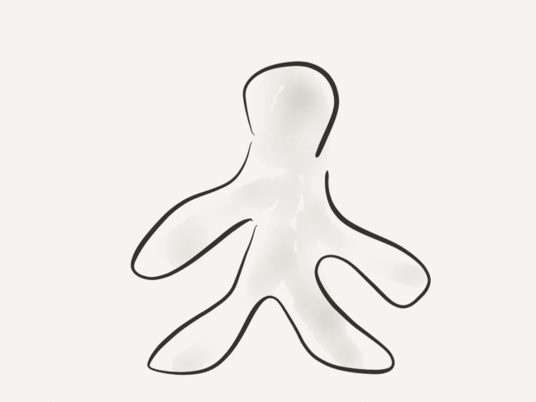

This game involves 8-12 team members working together and using their bodies to form letters and words.

Find an area that is free of obstacles and ask participants to spread out. The challenge can be made tough level by level, with participants starting with individual alphabets, then 3-4 letter words and then finally small phrase or sentence. One member from the team is excluded of the physical work and is asked to guess the human formations.

The team with maximum number of correct guesses wins. The activity can be fast paced with time limit to keep the group energized. It drives important learning outcomes of creative thinking, planning, support and trust.

45) Earth-ball



Goal setting is equally important for creating highly functional teams.

This group task ensures this and more. The team members are instructed to keep a beach ball or balloon in the air for specified number of hits without letting it hit the ground.

Additionally, no one person can touch the ball twice in a row. Ask the group the number of hits they can manage before they start with the activity. This fun activity is much harder than it seems! If the group is struggling, give them an opportunity to review their strategy and create a plan for the next attempt. The team with highest number of hits in one attempt is the winner.

46) Calculator

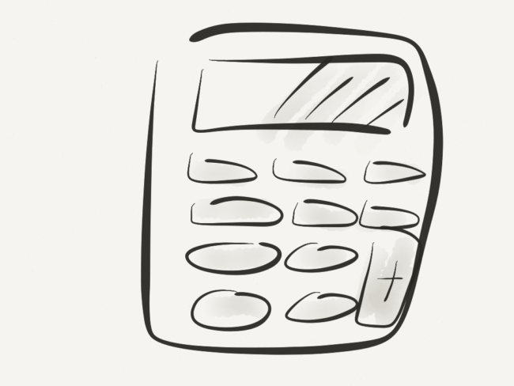

The game is high on testing a team’s ability to work in tandem, strategize and allow for effective leadership.

A pit is made with duct tape in a rectangular shape. Paper cards marked 1 to 20 are placed within the pit in a random fashion. Make team of 4-5 members each. Instruct them to nominate a leader. The goal of the game is to have each of the team to touch the numbers from 1 to 20 in sequence. The challenges of the game include:

1) Before playing, only the leaders of each of the teams are allowed to have sneak peek of the pit for 1 minute and task is explained to them

2) Leaders should go back and explain their team about the task and also strategize with members who have not seen the pit

3) Everyone in the team must touch some number

4) No person can touch two numbers in a row

5) Everyone must remain outside of the calculator and only reach in the pit to touch their number

47) All Together



Ask the group to find a partner and pair up.

The pairs sit on the ground with their backs to each other. The partners then reach behind their backs to link arms with each other.  When the instructor says, “Go,” the partners attempt to stand up without separating. To make it challenging, you can specify that the partners can’t talk to each other.

This activity is a fun way to learn about coordination and unspoken trust that helps smooth team functioning at work.

48) Who am I?



Stereotypes often act as a hindrance in way of amazing teamwork.

To break the groups’ prejudices, the game of “Who am I?” is as perfect as it can get. Make index cards/name tags of different types of people like ‘Go-Getter’, ‘Lazy’ ‘Grumpy’, ‘Authoritative’, ‘nerdy’ etc. Place these tags on the back of the person so that they can’t see it but the others can.

For a set amount of time let the group mingle and ask each person to guess what their label is by the way other members act towards them. As each team member figures out who they are, they can exit the game and let the rest continue.

49) Gutter Ball

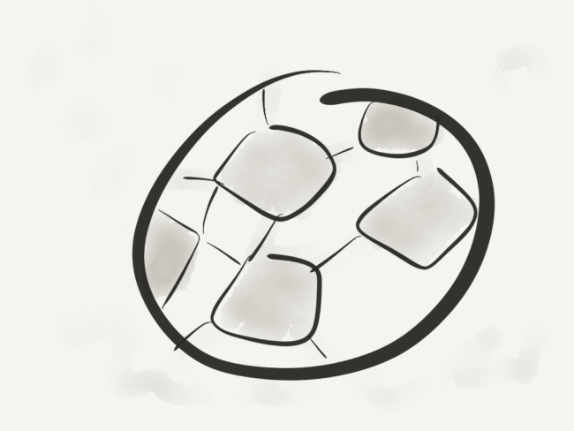

This game involves moving marbles or different sized balls down the lengths of half pipe with each participant having only a short length of pipe.

The instructor can put obstacles between start and end point so that the members have a tough time in balancing and transferring the marbles/balls from one pipe to other. The teams can be given 5 minutes of time to plan and form their strategy.

The team that finishes the activity in least amount of time is the winner. This group exercise helps to emphasize the role of each member in the team to tackle problems and move towards a common goal.

50) Swift Swap



This game acts as a refresher for teams that are feeling drained and stressed out.

It serves as a great team activity for groups that have not interacted for a long time or only know each other remotely. It can be done with 10-20 people. Participants will need to form two equal lines facing each other and are given observation period of 15 seconds. The game starts when one line turns around, giving the second line 30-40 seconds to change 10 things about themselves.

This can include anything from jewelry or clothing being swapped with other people, untied shoelaces, a different hair do, or a switched watch or ring to the other hand. All changes must be something the other group can see. After 40 seconds, the first group turns around and tries to find all the changes the other group made. Once the changes have been recognized, the groups switch, giving each team a chance to make changes.

All the above listed team building games serve single most important mission – “Teamwork creates Dreamwork”.

Norberts.

* * *

Technology can have huge impact on Teamwork. Let your teams work seamlessly without scheduling conflicts. How? Explore our software that is high on transparency and low on confusion. Visit us at [CakeHR](http://cake.hr/?utm_source=blog) for more information!

[games](https://blog.cake.hr/tag/games/) [motivation](https://blog.cake.hr/tag/motivation-2/) [teambuilding](https://blog.cake.hr/tag/teambuilding/)

Written By



[Norberts Erts](https://blog.cake.hr/author/norberts/)

Co-founder of CakeHR. Keeping a sharp eye on international news, politics, business, finance, science, technology and the connections between them.

Read Next

[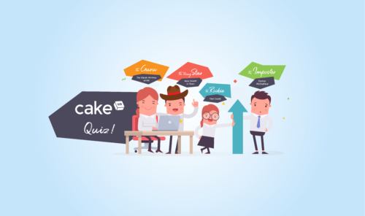](https://blog.cake.hr/strong-hr-game-take-the-hr-quiz-find-out-your-true-hr-personality/)

[Interesting](https://blog.cake.hr/category/interesting/)

[How Strong Is Your HR Game? Take the HR Quiz to Find Out Your True HR Personality!](https://blog.cake.hr/strong-hr-game-take-the-hr-quiz-find-out-your-true-hr-personality/)

Fancy yourself as the next big Human Resources virtuoso? Let’s see shall we?

[Kaspars Upmanis](https://blog.cake.hr/author/admin/)

June 3rd, 2018

[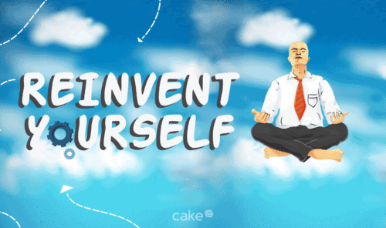](https://blog.cake.hr/how-to-reinvent-yourself-as-an-entrepreneur/)

[Interesting](https://blog.cake.hr/category/interesting/)

[10 Great Tips on How to Reinvent Yourself as an Entrepreneur](https://blog.cake.hr/how-to-reinvent-yourself-as-an-entrepreneur/)

Learning how to reinvent yourself and start anew can be one of the biggest challenges you’ll ever face as an entrepreneur, especially after experiencing failure or a set back. But with the right outlook and the right attitude, you can create a whole new you.

[Bryan Zarpentine](https://blog.cake.hr/author/bryan/)

August 22nd, 2016

[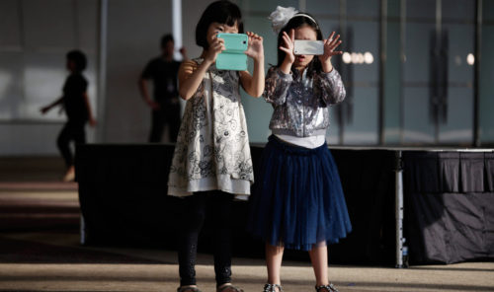](https://blog.cake.hr/generation-z-move-over-millenials/)

[Interesting](https://blog.cake.hr/category/interesting/)

[Move over Millenials: Here Comes Generation Z](https://blog.cake.hr/generation-z-move-over-millenials/)

Generation Z and the workforce

[Pet Smith](https://blog.cake.hr/author/pet/)

April 27th, 2015

[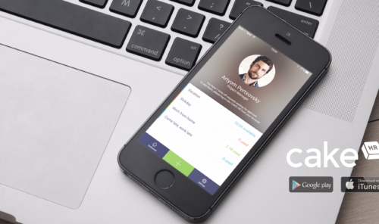](https://blog.cake.hr/new-ios-android-app-cakehr/)

[CakeHR](https://blog.cake.hr/category/cakehr/)

[The all new iOS and Android app from CakeHR takes “on-the-go” one step further](https://blog.cake.hr/new-ios-android-app-cakehr/)

Employee leave management now from your mobile device

[Lee Francis Chapman](https://blog.cake.hr/author/lee/)

June 1st, 2016

Easy-to-implement HR tips  
delivered to Your inbox!

Top of Form

